What is Thermodynamics?
Thermodynamics in physics is a branch that deals with heat, work and temperature, and their relation to energy, radiation and physical properties of matter.
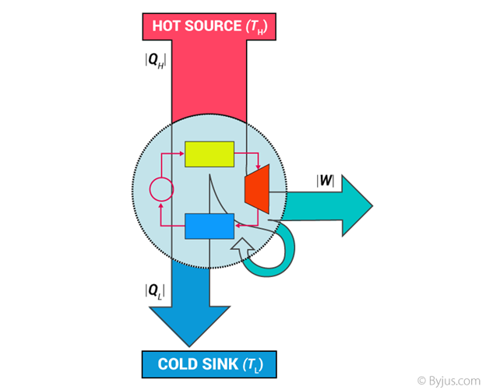
To be specific, it explains how thermal energy is converted to or from other forms of energy and how matter is affected by this process. Thermal energy is the energy that comes from heat. This heat is generated by the movement of tiny particles within an object. The faster these particles move, the more heat is generated.
Thermodynamics is not concerned about how and at what rate these energy transformations are carried out but is based on initial and final states of a system undergoing the change. It should also be noted that Thermodynamics is a macroscopic science. This means that it deals with the bulk system and does not deal with the molecular constitution of matter.

Distinction Between Mechanics and Thermodynamics
The distinction between mechanics and thermodynamics is worth noting. In mechanics, we solely concentrate on the motion of particles or bodies under the action of forces and torques. Thermodynamics, on the other hand, is not concerned with the motion of the system as a whole. It is only concerned with the internal macroscopic state of the body.

Different Branches of Thermodynamics
Thermodynamics is classified into the following four branches:
- Classical Thermodynamics
- Statistical Thermodynamics
- Chemical Thermodynamics
- Equilibrium Thermodynamics

Classical Thermodynamics
In classical thermodynamics, the behaviour of matter is analyzed with a macroscopic approach. Units such as temperature and pressure are taken into consideration which helps the individuals to calculate other properties and to predict the characteristics of the matter that is undergoing the process.

Statistical Thermodynamics
In statistical thermodynamics, every molecule is under the spotlight i.e. the properties of each and every molecule and ways in which they interact are taken into consideration to characterize the behaviour of a group of molecules.

Chemical Thermodynamics
Chemical thermodynamics is the study of how work and heat relate to each other both in chemical reactions and in changes of states.

Equilibrium Thermodynamics
Equilibrium thermodynamics is the study of transformations of energy and matter as they approach the state of equilibrium.

Basic Concepts of Thermodynamics – Thermodynamic Terms
Thermodynamics has its own unique vocabulary associated with it. Good understanding of the basic concepts forms a sound understanding of various topics discussed in thermodynamics preventing possible misunderstandings.

Thermodynamic Systems
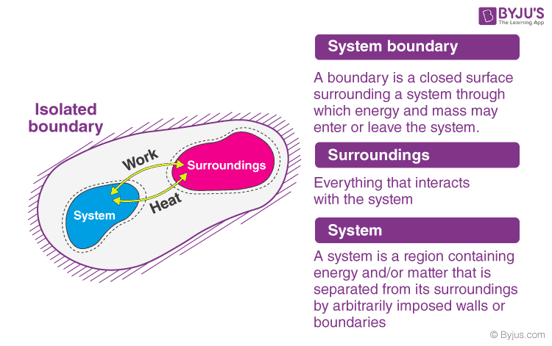

System
A thermodynamic system is a specific portion of matter with a definite boundary on which our attention is focussed. The system boundary may be real or imaginary, fixed or deformable.
There are three types of system as:
- Isolated System – An isolated system cannot exchange both energy and mass with its surroundings. The universe is considered an isolated system.
- Closed System – Across the boundary of the closed system, the transfer of energy takes place but the transfer of mass doesn’t take place. Refrigerator, compression of gas in the piston-cylinder assembly are examples of closed systems.
- Open System – In an open system, the mass and energy both may be transferred between the system and surroundings. A steam turbine is an example of an open system.

Interactions of thermodynamic systems
Type of system | Mass flow | Work | Heat
Isolated System | ☓ | ☓ | ☓
Open System | ✓ | ✓ | ✓
Closed System | ☓ | ✓ | ✓

Surrounding
Everything outside the system that has a direct influence on the behaviour of the system is known as a surrounding.

Thermodynamic Process
A system undergoes a thermodynamic process when there is some energetic change within the system that is associated with changes in pressure, volume and internal energy.
There are four types of thermodynamic process that have their unique properties, and they are:
- Adiabatic Process – A process where no heat transfer into or out of the system occurs.
- Isochoric Process – A process where no change in volume occurs and the system does no work.
- Isobaric Process – A process in which no change in pressure occurs.
- Isothermal Process – A process in which no change in temperature occurs.
C_{p} – C_{v} = R
A thermodynamic cycle is a process or a combination of processes conducted such that the initial and final states of the system are the same. A thermodynamic cycle is also known as cyclic operation or cyclic processes.

Thermodynamic Properties
Thermodynamic properties are defined as characteristic features of a system, capable of specifying the system’s state. Thermodynamic properties may be extensive or intensive.
- Intensive properties are properties that do not depend on the quantity of matter. Pressure and temperature are intensive properties.
- In the case of extensive properties, their value depends on the mass of the system. Volume, energy, and enthalpy are extensive properties.

What is Enthalpy?
Enthalpy is the measurement of energy in a thermodynamic system. The quantity of enthalpy equals the total content of heat of a system, equivalent to the system’s internal energy plus the product of volume and pressure.
Mathematically, the enthalpy, H, equals the sum of the internal energy, E, and the product of the pressure, P, and volume, V, of the system.
H = E_{int} + PV

What is Entropy?
The entropy is a thermodynamic quantity whose value depends on the physical state or condition of a system. In other words, it is a thermodynamic function used to measure the randomness or disorder of a system.
For example, the entropy of a solid, where the particles are not free to move, is less than the entropy of a gas, where the particles will fill the container.

Thermodynamic Potentials
Thermodynamic potentials are quantitative measures of the stored energy in a system. Potentials measure the energy changes in a system as they evolve from initial state to final state. Based on the system constraints, such as temperature and pressure, different potentials are used.
Different forms of thermodynamic potentials along with their formula are tabulated below:
Internal Energy | U=∫TdS−PdV+∑iμidNi
Helmholtz free energy | F = U – TS
Enthalpy | H = U + PV
Gibbs Free Energy | G = U + PV – TS

Solved Problems on Thermodynamics
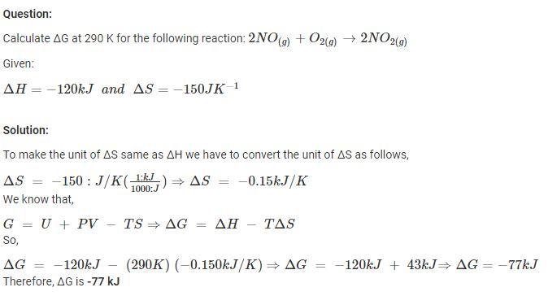

Entropy
Entropy is defined as "a measure of the disorder or randomness in a closed system," which also inexorably increases. You can mix hot and cold water, but because a large cup of warm water is more disordered than two smaller cups containing hot and cold water, you can never separate it back into hot and cold without adding energy to the system.
All thermodynamic systems generate waste heat. This waste results in an increase in entropy, which for a closed system is "a quantitative measure of the amount of thermal energy not available to do work," according to the American Heritage Dictionary. Entropy in any closed system always increases; it never decreases. Additionally, moving parts produce waste heat due to friction, and radiative heat inevitably leaks from the system.

Difference between Enthalpy and Entropy
Enthalpy is the measure of total heat present in the thermodynamic system where the pressure is constant.
It is represented as
ΔH=ΔE+PΔV
where E is the internal energy, P is the pressure and E is the energy.
Entropy is the measure of disorder in a thermodynamic system. It is represented as
ΔS=ΔH/T
where Q is the heat content and T is the temperature.
Difference between Enthalpy and Entropy
Enthalpy | Entropy
Enthalpy is a kind of energy. | Entropy is a property.
It is the sum of the internal energy and the flow of energy | It is the measurement of the randomness of molecules.
It is denoted by the symbol H | It is denoted by the symbol S
It was termed by a scientist named Heike Kamerlingh Onnes. | It was termed by a scientist named Rudolf Clausius.
Its unit is Jmol⁻¹ | Its unit is JK⁻¹
It is applicable to related standard conditions. | It does not have any limits or conditions.
The system favours minimum enthalpy<./td> | The system favours maximum entropy.

The four laws of thermodynamics
The fundamental principles of thermodynamics were originally expressed in three laws. In brief, these laws are:
The Zeroth (0) Law states that if two bodies are in thermal equilibrium with some third body, then they are also in equilibrium with each other. This establishes temperature as a fundamental and measurable property of matter.

An example demonstrating the Zeroth Law
C
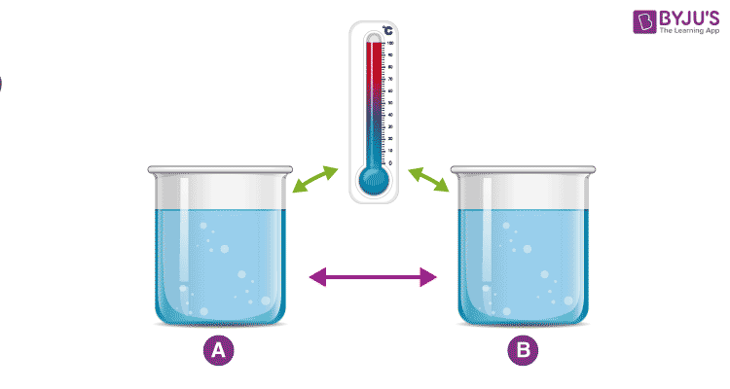
The First Law states that the total increase in the energy of a system is equal to the increase in thermal energy plus the work done on the system. This states that heat is a form of energy and is therefore subject to the principle of conservation.
First Law Of Thermodynamics Examples:
Plants convert the radiant energy of sunlight to chemical energy through photosynthesis. We eat plants and convert the chemical energy into kinetic energy while we swim, walk, breathe and when we scroll through this page.
Switching on light may seem to produce energy, however, it is electrical energy that is converted.

Explaining the first law of thermodynamics
The first law of thermodynamics relates to heat, internal energy, and work.
The first law of thermodynamics, also known as the law of conservation of energy states that energy can neither be created nor destroyed, but it can be changed from one form to another.
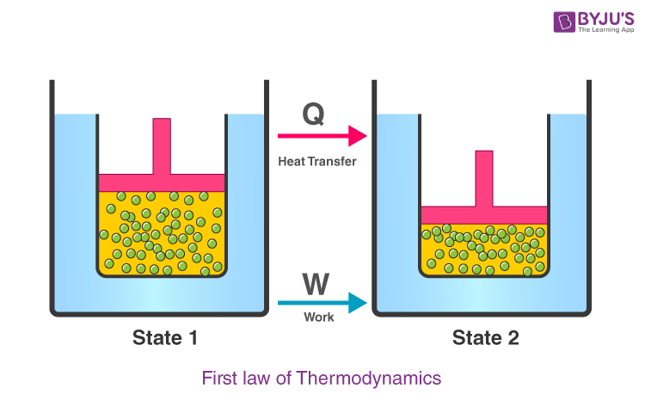
According to this law, some heat given to the system is used to change the internal energy while the rest is used in doing work by the system.
It can be represented mathematically as
ΔQ=ΔU+W, ΔU = Internal energy
Where,
- ΔQ is the heat given or lost
- ΔU is the change in internal energy
- W is the work done
We can also represent the above equation as follows,
ΔU=ΔQ−W
So we can infer from the above equation that the quantity (ΔQ – W) is independent of the path taken to change the state. Further, we can say that internal energy tends to increase when the heat is given to the system and vice – versa. Work is also equal to the negative external pressure on the system multiplied by the change in volume:
w=−pΔV; w = force x distance = (p. ΔA).d = p.V (V=A.d)
where P is the external pressure on the system, and ΔV is the change in volume. This is specifically called "pressure-volume" work.
Table 1
Process | Sign of heat (q) | Sign of Work (w)
Work done by the system | N/A | -
Work done onto the system | N/A | +
Heat released from the system- exothermic (absorbed by surroundings) | - | N/A
The above figure is a visual example of the First Law of Thermodynamics. The blue cubes represent the system and the yellow circles represent the surroundings around the system. If energy is lost by the cube system then it is gained by the surroundings. Energy is never created nor destroyed. Since the area of the clue cube decreased the visual area of the yellow circle increased. This symbolizes how energy lost by a system is gained by the surroundings. The affects of different surroundings and changes on a system help determine the increase or decrease of internal energy, heat and work.
Table 2
The Process | Internal Energy Change | Heat Transfer of Thermal Energy (Q) | Work (w=-PΔV) | Example
Q=0 Adiabatic | + | 0 | + | Isolated system in which heat does not enter or leave similar to styrofoam
ΔV=0 Constant Volume | + | + | 0 | A hard, pressure isolated system like a bomb calorimeter
Constant Pressure | + or - | enthalpy (ΔH) | -PΔV | Most processes occur are constant external pressure
ΔT=0 Isothermal | 0 | + | - | There is no change in temperature like in a temperature bath
Example 11
A gas in a system has constant pressure. The surroundings around the system lose 62 J of heat and does 474 J of work onto the system. What is the internal energy of the system?
Solution
To find internal energy, ΔU, we must consider the relationship between the system and the surroundings. Since the First Law of Thermodynamics states that energy is not created nor destroyed we know that anything lost by the surroundings is gained by the system. The surrounding area loses heat and does work onto the system. Therefore, q and w are positive in the equation ΔU=q+w because the system gains heat and gets work done on itself.
ΔU=(62J)+(474J)=536J; ΔU=(62J)+(474J)=536J
Example 22
A system has constant volume (ΔV=0) and the heat around the system increases by 45 J.
- What is the sign for heat (Q) for the system?
- What is ΔU equal to?
- What is the value of internal energy of the system in Joules?
Solution
Since the system has constant volume (ΔV=0) the term -PΔV=0 and work is equal to zero. Thus, in the equation ΔU=Q+w, w=0 and ΔU=Q. The internal energy is equal to the heat of the system. The surrounding heat increases, so the heat of the system decreases because heat is not created nor destroyed. Therefore, heat is taken away from the system making it exothermic and negative. The value of Internal Energy will be the negative value of the heat absorbed by the surroundings.
- negative (Q<0)
- ΔU=Q + (-PΔV) = Q+ 0 = Q
- ΔU = -45J

Sign Conventions
The table below shows the appropriate sign conventions for all three quantities under different conditions:
ΔU (change in internal energy) | Q (heat) | W (work done on the gas)
is “+” if temperature increases | is “+” if heat enters gas | is “+” if gas is compressed
is “-” if temperature decreases | is “-” if heat exist gas | is “-” if gas expands
is “0” if temperature is constant | is “0” if no heat is exchanged | is “0” if volume is constant

First Law of Thermodynamics Solved Examples
1. Calculate the change in the internal energy of the system if 3000 J of heat is added to a system and a work of 2500 J is done.
Solution:
The following sign conventions are followed in the numerical:
Solution:
The following sign conventions are followed in the numerical:
- Q is positive as heat is added to the system
- W is positive if work is done on the system
Hence, the change in internal energy is given as:
ΔU=3000−2500
ΔU=500
The internal energy of the system is 500 J.
2. What is the change in the internal energy of the system if 2000 J of heat leaves the system and 2500 J of work is done on the system?
Solution:
The change in the internal energy of the system can be identified using the formula:
ΔU = Q-W
Substituting the values in the following equation, we get
ΔU = -2000-(-3000)
ΔU = -2000+3000
ΔU = 1000 Joule
Internal energy increases by 4500 Joules.

The Second Law states that heat energy cannot be transferred from a body at a lower temperature to a body at a higher temperature without the addition of energy. This is why it costs money to run an air conditioner.

The entropy of the universe only increases and never decreases. Many individuals take this statement lightly and for granted, but it has an extensive impact and consequence.

Visualizing the second law of thermodynamics
If a room is not tidied or cleaned, it invariably becomes more messy and disorderly with time. When the room is cleaned its entropy decreases but the effort to clean it has resulted in an increase in entropy outside the room that exceeds the entropy lost.

Different Statements of The Law
There are two statements on the second law of thermodynamics which are;
- Kelvin- Plank Statement
- Clausius Statement

Kelvin-Planck Statement
It is impossible for a heat engine to produce a network in a complete cycle if it exchanges heat only with bodies at a single fixed temperature.
Exceptions:
If Q₂ =0 (i.e., W_{net} = Q₁, or efficiency=1.00), the heat engine produces work in a complete cycle by exchanging heat with only one reservoir, thus violating the Kelvin-Planck statement.

Clausius’s Statement
It is impossible to construct a device operating in a cycle that can transfer heat from a colder body to warmer without consuming any work.
In other words, unless the compressor is driven by an external source, the refrigerator won’t be able to operate.
Heat pump and Refrigerator works on Clausius’s statement.
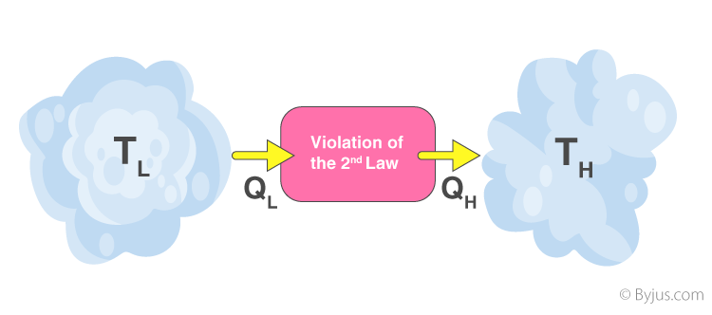
Both Clausius’s and Kelvin’s statements are equivalent i.e a device violating Clausius’s statement will also violate Kelvin’s statement and vice versa.
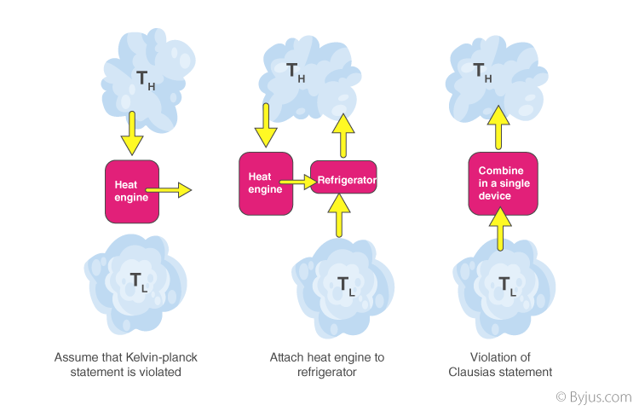
In addition to these statements, a French physicist named Nicolas Léonard Sadi Carnot also known as”father of thermodynamics,” basically introduced the Second Law of Thermodynamics. However, as per his statement, he emphasized the use of caloric theory for the description of the law. Caloric (self repellent fluid) relates to heat and Carnot observed that some caloric was lost in the motion cycle.

Perpetual Motion Machine of the Second Kind (PMM2)
The device that produces work while interacting with a single heat reservoir is known as a perpetual motion machine of the second kind (PMM2). Also, a device that violates the second law of thermodynamics is a perpetual motion machine of the second kind.
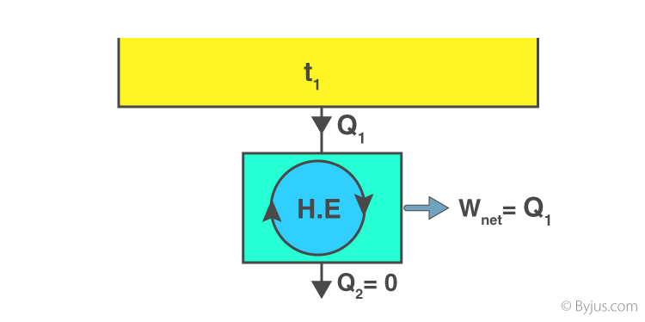
Thus, a heat engine has to interact with at least two thermal reservoirs at different temperatures to produce work in a cycle. So long as there is a difference in temperature, motive power (i.e., work) can be produced. If the bodies with which the heat engine exchange heat are of finite heat capacities, work will be produced by the heat engine until the temperature of the two bodies is equalised.
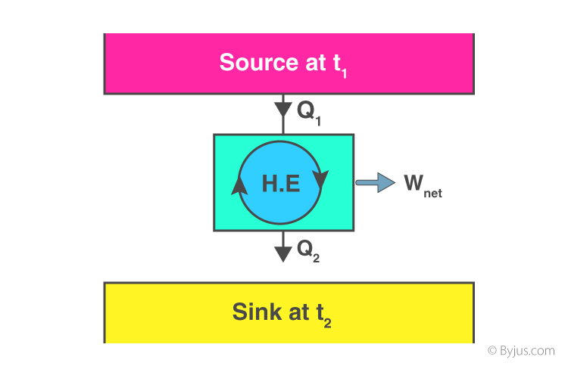

Solved Examples of Second Law Of Thermodynamics
1. A heat pump uses 300 J of work to remove 400 J of heat from the low-temperature reservoir. How much heat is delivered to a higher temperature reservoir?
Solution:
W = 300 J
Q_{C} = 400 J
Q_{H =} W + Q_{C}
Q_{H =} 300 J + 400 J
Q_{H =} 700 J
Heat delivered to the higher temperature reservoir is 700 J.
2. A reversible heat engine receives 4000 KJ of heat from a constant temperature source at 600 K . If the surroundings is at 300K. determine the (a) the availability of heat energy, (b) Unavailable heat.
Solution:
Q₁ = 4000 KJ
T₁ = 600K
T₀ = 300 K
Change in entropy\left ( \Delta S \right ) = \int \frac{dQ}{T}Changeinentropy(ΔS)=∫TdQ​ \Delta S = \frac{Q_{1}}{\left ( T_{1}+T_{0} \right )}ΔS=(T1​+T0​)Q1​​
Change in entropy = 4.44 KJ/K
The availability of heat energy,
A = Q₁ – T₀(ΔS)
A = 4000 – 300(4.44)
A = 2,668 KJ.
Unavailable heat (U.A) = T₀ (ΔS)
(U.A) = 300 (4.44)
(U.A) = 1332 KJ.
(a) the availability of heat energy (A) = 2668 KJ
(b)Unavailable heat (U.A) = 1332 KJ
The Third Law states that the entropy of a pure crystal at absolute zero is zero. As explained above, entropy is sometimes called "waste energy," i.e., energy that is unable to do work, and since there is no heat energy whatsoever at absolute zero, there can be no waste energy. Entropy is also a measure of the disorder in a system, and while a perfect crystal is by definition perfectly ordered, any positive value of temperature means there is motion within the crystal, which causes disorder. For these reasons, there can be no physical system with lower entropy, so entropy always has a positive value.

